Configuration of IKEv2 VPN on a Android 11 smartphone
(2021-01-07, mtodorov, used Samsung A22 5G Android smartphone.)
It is necessary to install VPN client certificate generated as described here: https://libreswan.org/wiki/VPN_server_for_remote_clients_using_IKEv2#Example_certificate_generation_with_certutil
- In our case, the administrators distribute VPN client key over the Apache2 server. Select the link:
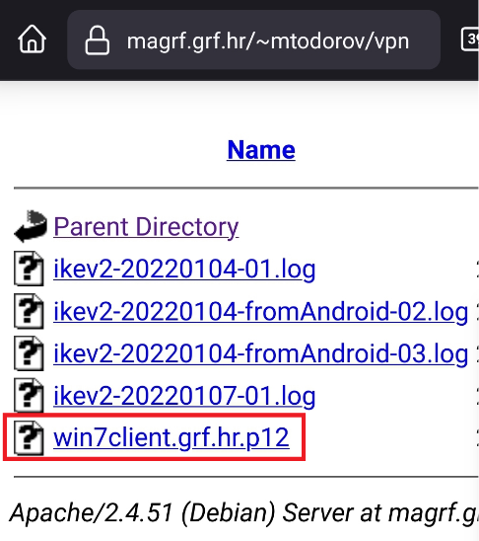
- Download the client key:
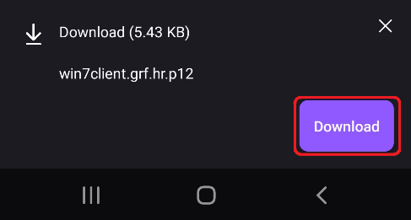
- Choose Open after the download:
- Select „Certificate installer“ and „Just once“:
- Type the certificate password and press OK:
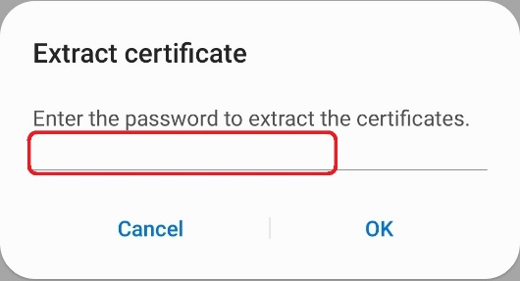

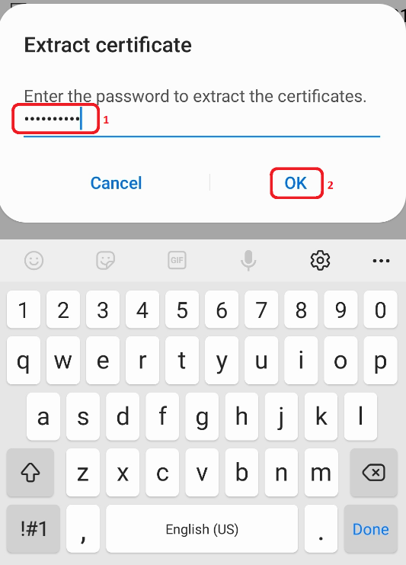
- Choose VPN or app certificate:
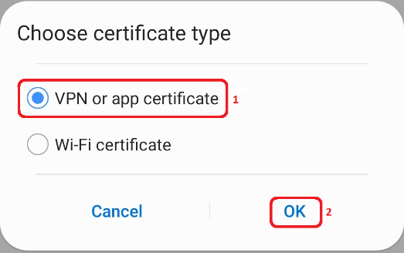
- Type the name for the certificate you will use in the later step 11:
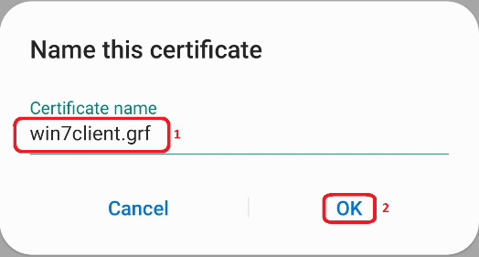
- Go into the „Settings“ dialogue of your Android phone, then choose Connections, then „More connection settings“:
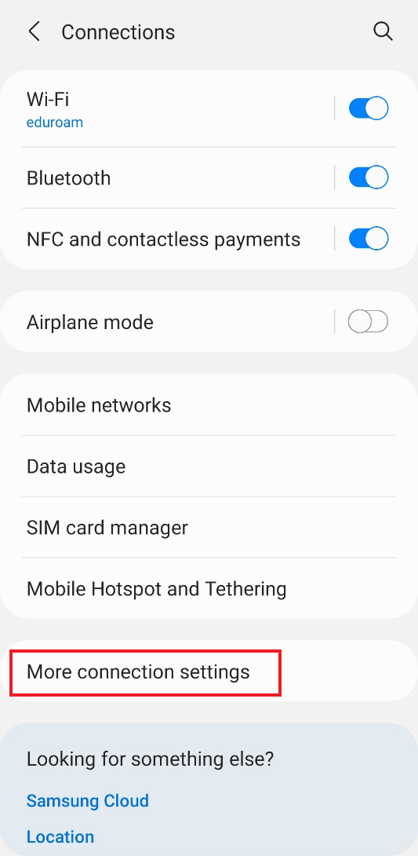
- Choose „VPN“:
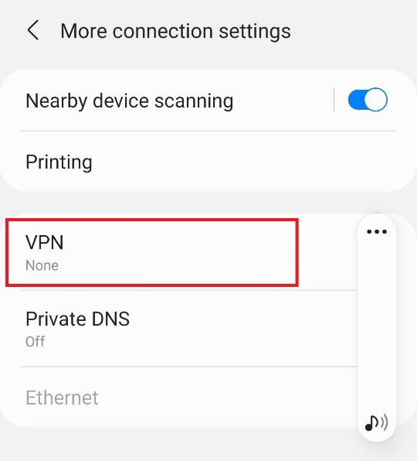
- Choose three vertical dots: ⋮ in the upper right corner, then „Add VPN profile“
- Fill in the VPN network wizard:
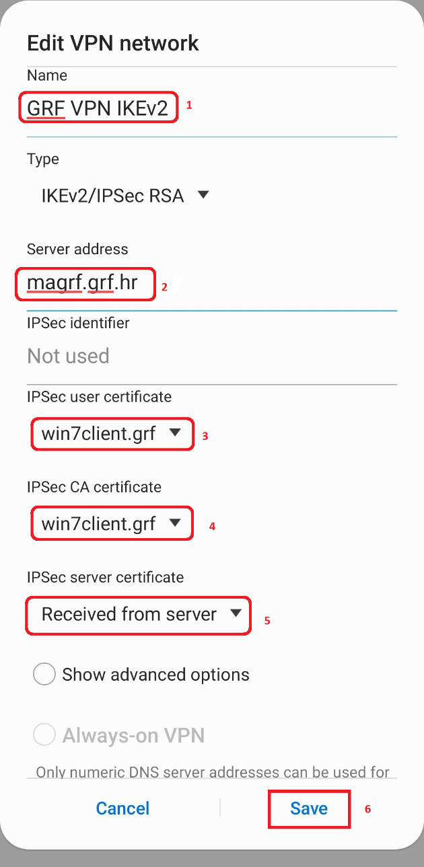
NOTE: we „cheat“ the wizard and supply windown client certificate as the IPSec CA (root) certificate.
- Choose the VPN connection by the name you have given it in the step 11, the choose connect:
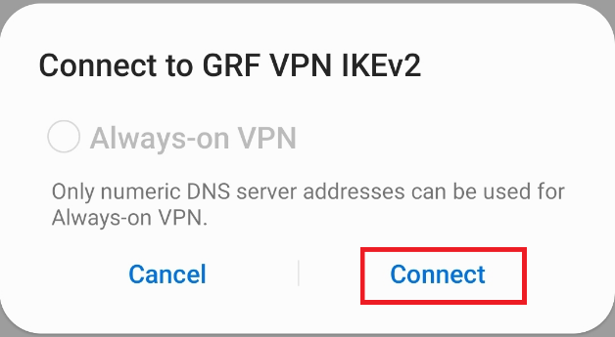

- Now the VPN is connected:

Finished 2022-01-07 15:17 UTC+01

